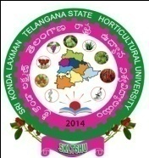

SRI KONDA LAXMAN TELANGANA STATE HORTICULTURAL UNIVERSITY
Administrative Office, Mulugu (V&M), Siddipet (Dist) – 502 279

Notification for Admissions into
M.Sc. (Hort.) and Ph.D. (Hort.) Courses – 2023-24

Advt.No.14/PG Acad./2023, Dt:03.11.2023

Applications are invited for admission into M.Sc. (Hort.) with specialization in 1) Fruit Science, 2) Vegetable Science, 3) Floriculture & Landscaping and 4) Plantation, Spices, Medicinal and Aromatic Crops from candidates possessing B.Sc.(Hort.)/B.Sc.(Hons.) Horticulture and for Ph.D. (Hort.) from candidates with M.Sc. (Hort.) degree. Applications and Prospectus may be downloaded from the SKLTSHU website: www.skltshu.ac.in. Last date for receipt of filled in applications is 20.11.2023 by 04.00 P.M.

Dr. A. BHAGWAN
REGISTRAR

Note: To be published in English Language only.

